https://wordpress.org/plugins/wp-google-search/:

WP Google Search (wordpress.org)

Contents
Details 2
Description 2
Available Languages 2
Screenshots 2
FAQ 3
Documentation / FAQ 3
Contributors and Developers 7
Installation 7

Details

Description
If you would like a Google search feature on your WordPress site, you only need to register to Google Custom Search, get your Google Search Engine ID, and enter it in the plugin settings page.
Then your custom search engine is ready for use, just put the new Google search box widget on the sidebar, and enjoy it!
In this way the plugin enables you to insert Google search into your website, or a collection of websites easily. You can search both web pages and images.
You can define if you want to search only on your site (or given sites), or the entire web.
It is possible to customize your search features, the look and feel (layout, themes, custom colors and fonts, thumbnails), and much more.
All these settings can be specified on the Google Custom Search Engine admin site: https://www.google.com/cse/
Your changes will appear instantly on your site automatically.
After you registered to Google Custom Search Engine and get your Google Search Engine ID, you need to enter the ID in the plugin settings page: Settings -> WP Google Search
Use WP Google Search widget or [wp_google_searchbox] shortcode to place search box on your site.
Search results can be displayed on a normal page or in a popup window. Use Full Width layout or Overlay (popup) layout on Google Custom Search Admin site to setup it.
It does not require any coding or other complicated operation.
Please find more information in the product documentation:
WP Google Search Documentation

Available Languages
- English
- Spanish – translated by Ogi Djuraskovic – http://firstsiteguide.com
- Serbian – translated by Ogi Djuraskovic – http://firstsiteguide.com
- Portuguese (BR) – translated by Gabriel Froes
- Swedish – translated by Tobias – http://ComClick.se
- Danish – translated by Alexander Leo-Hansen – http://alexanderleohansen.dk
- Russian – translated by Timofeev Ilya

Screenshots
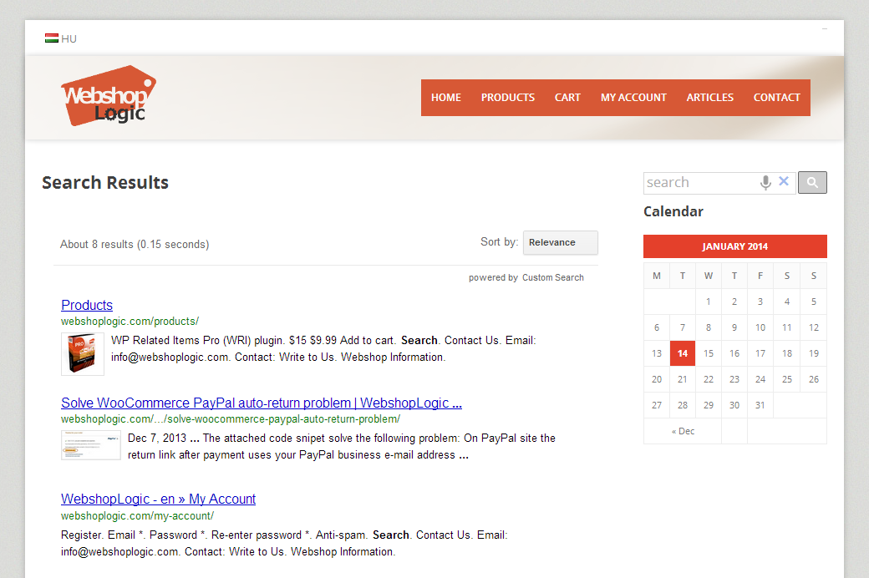 | 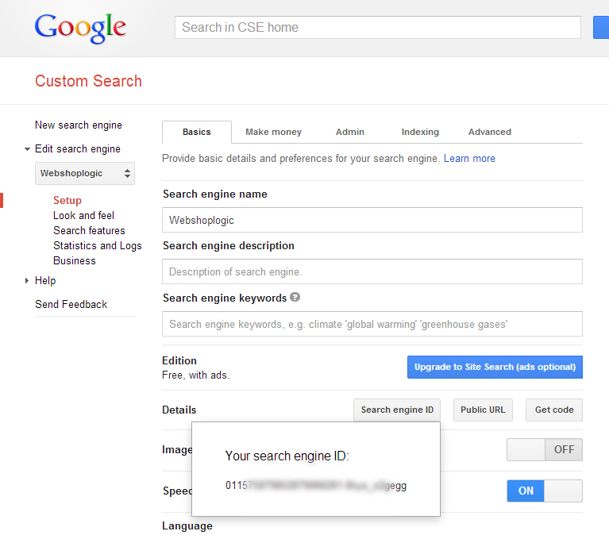 | 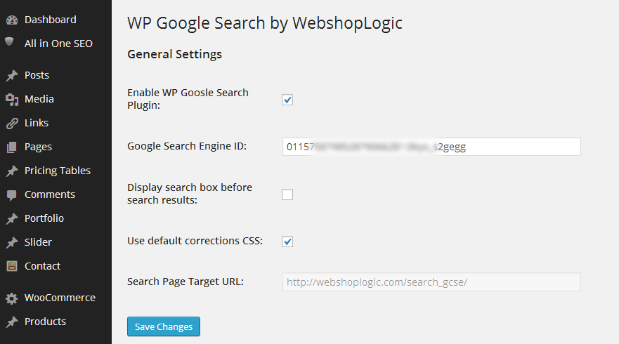 | 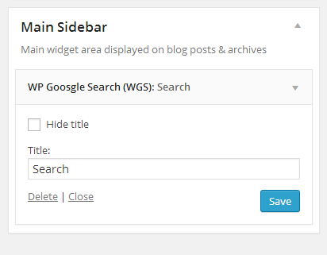 | 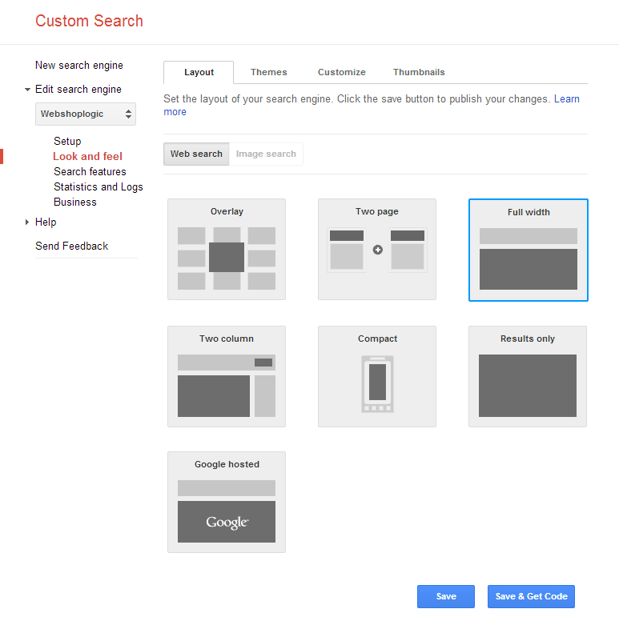 | 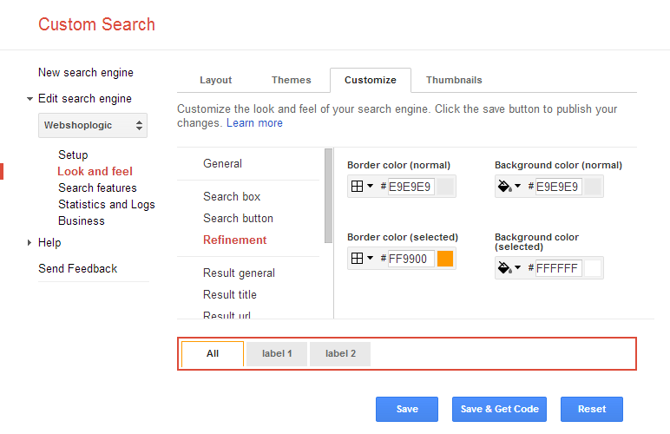

FAQ
You can find FAQ here:

Documentation / FAQ
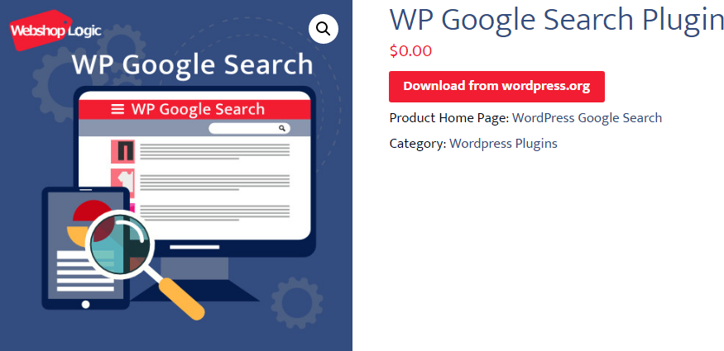

How to set Google Custom Search?
You have to do the following 3 easy steps to make all the registrations and settings.
- Register to Google Custom Search
Register to Google Custom Search Engine and get your Google Search Engine ID on the Google Custom Search Engine admin site: https://www.google.com/cse/
If you want, that only your site can be searched, set your site as the only searchable site on “Sites to search” section.
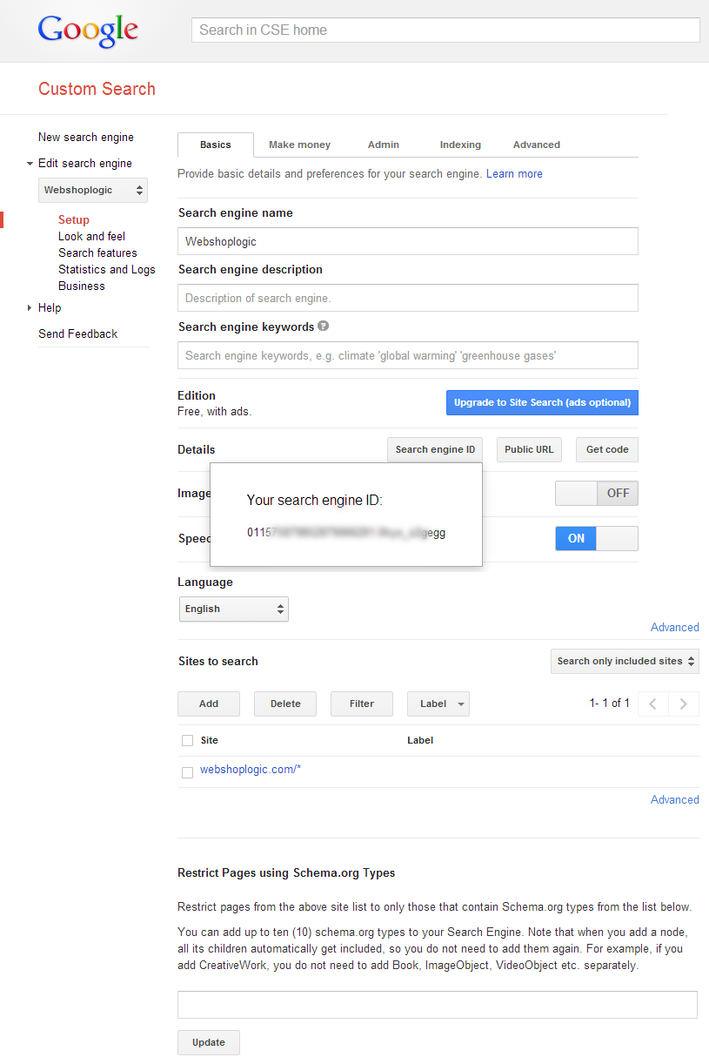You can make a lot of settings here; your changes will appear instantly on your site automatically.
For example, you can set that search results are displayed on a normal page or in a popup window. Use Full-Width layout or Overlay (popup) layout on Google Custom Search Admin site to setup it.
- Make plugin settings
After you registered to Google Custom Search Engine and get your Google Search Engine ID, you need to enter the ID in the plugin settings page: Settings -> WP Google Search
- Place Google search box on your site
Use WP Google Search widget or use [wp_google_searchbox] shortcode to place search box on your site.

What should I do if there is a problem with displaying search results?
When you activate the plugin, it creates a “Search Results” page, the slug code of this page is “search_gcse”.
This page contains the following shortcode, where the plugin displays search results: [wp_google_search]
If there is any problem during display of search results, check that page is published and not scheduled.

Related Products
 |  | 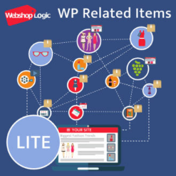
WooCommerce Custom Tabs Lite Plugin  $0.00   | WooCommerce Custom Tabs Pro Plugin  $23.00 – $94.00   | WP Related Posts and Products Lite plugin  $0.00

Contributors and Developers
“WP Google Search” is open source software. The following people have contributed to this plugin.
WebshopLogic

Installation
- Upload the plugin to the ‘/wp-content/plugins/’ directory.
- Activate it through the ‘Plugins’ menu in WordPress.
- Register to Google Custom Search Engine and get your Google Search Engine ID here: https://www.google.com/cse/
- Enable the plugin and enter Google Search Engine ID: Settings -> WP Google Search (See screenshots for more information.)

